Division or divinity?

New Thought Leaders Unify for Transformation!

April 24, 2020 ~ 3:00 PM PST

LIVE on ZOOM & facebook.com/globalnewthought
FREE TO EVERYONE

PLEASE ANNOUNCE WIDELY.
SHARE THIS DOCUMENT WITH MEDIA & COMMUNICATIONS PERSONNEL.

EVENT PAGE: https://www.agnt.today/events

TEXT - Press Release (to customize for cut/paste) + Flyer
https://www.agnt.today/download-center

LINK TO REGISTER ON ZOOM
FOR YOUR INVITATIONS & POSTS: Link to Webinar Registration page
https://zoom.us/webinar/register/WN_YODcQ_PrT6evh1gxmsTdJw

FaceBook LIVE
OR -- Join the broadcast LIVE STREAMED on our Facebook page on April 24th at the scheduled time, 3:00 PM, PST.
https://www.facebook.com/globalnewthought/

GRAPHICS (choose what you need..)

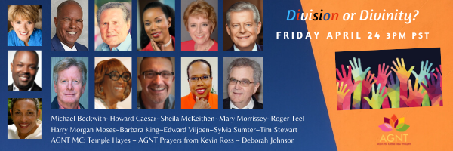
EMAIL BANNER
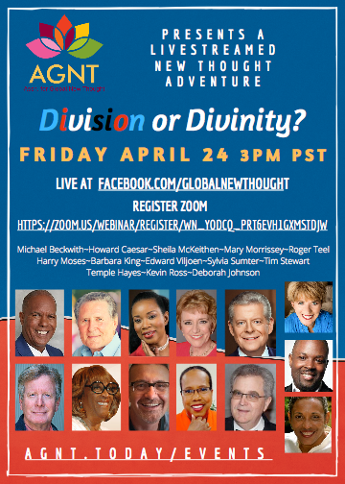
POSTER

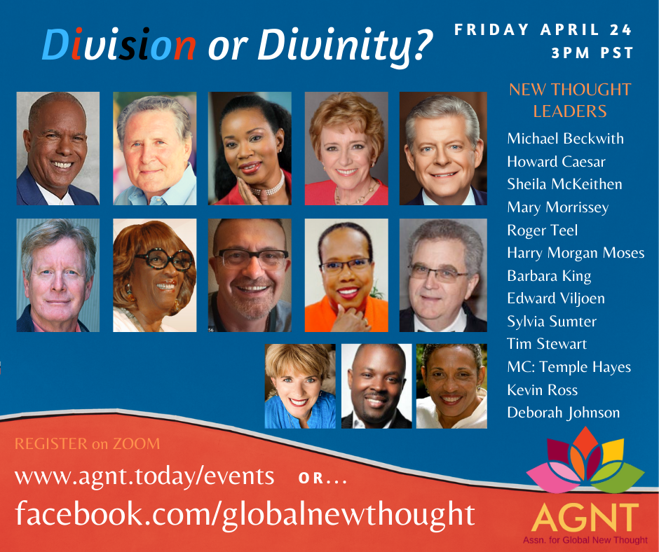
FB POST

