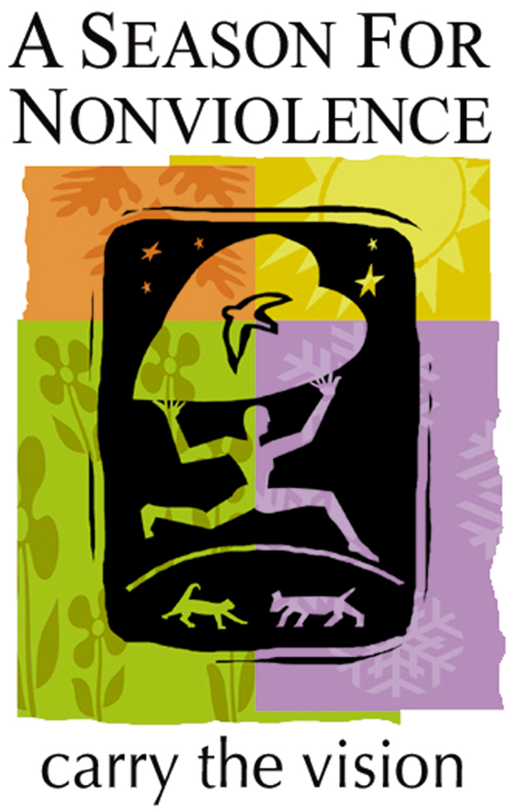
Honoring and Healing
our Relationship with All Earth Beings
through Compassion, Nonviolence
and Plant-Based Living

A Season for Nonviolence can assist in bringing compassion, kindness and reverence for the lives of nonhuman beings who suffer under the heavy hand of humanity. This behavior on the part of most of humanity is not aligned with our highest values of lovingkindness for all. The following bullet points can serve as a guideline for groups.
- Remembering that the liberation of every being and all of nature is inherently interconnected.
- Getting out of our comfort zones both physically and spiritually helps us question old patterns.
- Learning to eat plant-based meals and serving plant-based foods at events
- Reading books, watching videos and listening to presentations on animal exploitation and sentience and the rich meaning of veganism
- Inviting animal liberation speakers to address our groups
- Giving prayerful consideration to animal issues are all effective ways to widen our circle of compassion.
Through our group studies we can learn how the exploitation of animals is connected to exploitation of people and that all social justice and environmental issues are inextricably linked.
Together, we are on a learning journey, moving toward this revolutionary understanding.

Spiritually Guided Activism for Animal Liberation

CONDITION
Animal liberation works to eliminate violence and exploitation on the planet. Speciesism is the practice of treating members of one species [humans] as morally superior to members of other species, as well as the belief that this practice is justified. This false idea has perpetuated worldwide suffering and exploitation of animals for centuries.

UNDERLYING BELIEF CREATING THE CONDITION
A mostly unconscious belief that animals are here for the use of humanity, not for their own divine purpose. This leads to traditions, habits and actions that involve their domination, exploitation, and slaughter. When we do not question this belief we live without the joy of deeply knowing the sacredness of all life.

SPIRITUAL TRUTH
Isaac Bashevis Singer: “As long as people will shed the blood of innocent creatures, there can be no peace, no liberty, no harmony between people. Slaughter and justice cannot dwell together.”

Charles Fillmore, co-founder of Unity: “We need never look for universal peace on this earth until men stop killing animals for food. The lust for blood has permeated the race thought and the destruction of life will continue to repeat its psychology, the world round, until men willingly observe the law in all phases of life, ‘Thou shalt not kill.’”

PRAYER
Meister Eckhart: "Apprehend God in all things, for God is in all things. Every single creature is full of God and is a book about God. Every creature is a word of God. If I spent enough time with the tiniest creature—even a caterpillar—I would never have to prepare a sermon. So full of God is every creature."

May all beings everywhere be happy and free. May our thoughts, words and actions of this day contribute to that happiness and freedom for all beings. May we keep our compassion alive by eating in such a way that eliminates the suffering of living beings, stops contributing to climate change, and heals and preserves our precious planet.

Questions for Group Dialogue
Critical Opportunities CHALLENGES
- Have you ever considered living a plant-based life? Or do you feel that it is too great a challenge to stop eating animals?
- Are there people in your life with whom you feel you could talk about this?
- If you would like to take the challenge to abstain from meat, fish, eggs, and dairy products and eat only plant-based foods, how would that change affect animals?
- How would it affect you?
Taking the vegan challenge involves eliminating, as much as possible, activities and purchases that cause suffering to animals. This includes zoos, aquariums, fur, leather, down, rodeos, animal experimentation, hunting, etc. It is doing the most good and the least harm.

Guiding Principles VALUES
Most people would state enthusiastically that they would not knowingly or purposefully harm an animal, because that would be inconsistent with their values. Yet most eat animals and consume their milk and eggs, even though in today’s world, there are many compassionate options. This goes against the very values nearly all of us hold – kindness, compassion, non-violence and love.
What personal experiences have you had regarding the exploitation and killing of animals?

Transformative Practices METHODOLOGY
- When you are discussing or praying about Universal Love, Peace, Oneness, the Golden Rule or your love of animals, whom do you include in your circle of peace and love?
- When you hear people in your community talk about their spiritual values and love for all, do you offer ideas about expanding the circle of compassion to include animals?
- Do you bring plant-based meals to potlucks to share with others?
- How can we encourage open conversations about this?
These ideas and actions can be confronting because they threaten cultural and family traditions. as well as the deeply entrenched belief about human superiority.

Social Embodiment OUTCOMES
- How does the domination of other species manifest in family, friends and your spiritual community?
- What would community look like if all beings were respected and free from human cruelty?
- What are some efforts being made in the world toward that goal?
- What can you and your community do to raise consciousness and make the choice to do no harm to our fellow earthlings?

PLEDGE:
I pledge to learn more about the plight of animals caused by the anthropocentric belief that we have the right to cause needless suffering to other beings. I also pledge to expand my circle of compassion to include nonhuman animals, and move with commitment toward a plant-based diet and a vegan lifestyle, with faith, self-love, and respect for all.

LIVING OUR TRUE NATURE AS PEOPLE OF UNIVERSAL COMPASSION
Because AGNT values include lovingkindness, nonviolence, and peace, a step toward universal compassion involves applying the Golden Rule to all beings. For thousands of years, ever since human beings lost their connection to the sacredness of nature and other earthlings, anthropocentrism and the worldview that we have the right to dominate others has been used, consciously and unconsciously, by humanity to inflict unimaginable horrors on our animal cousins. Billions of innocent, defenseless animals are killed every year for food , experimentation, entertainment, sport hunting and fishing, wildlife control, and sonar testing. They are also killed by pollution from the poisons, trash and plastics we have created. These are not expressions of our true values.
While most of the world’s religions hold some version of the Golden Rule as their highest spiritual value and model for behavior, most have also fallen far short of this ideal. Though we have made some strides toward practicing lovingkindness toward people of different races, marginalized groups, women, and children, we continue to practice endless brutality toward billions of animals every year. Even if we do not participate directly in the abuse, torture, theft, and killing, we engage in it indirectly when we hire others to provide us with meat, eggs, dairy products; leather; down; household, beauty and medical products tested on animals; and more. These items are produced and bought at an enormous cost to animals – their own lives. We do this to beings who have done us no harm. The good news is when we simply refuse to purchase these products of pain, we become agents of liberation. We can save animals from this terrible war waged against them for millennia.
When we liberate animals from human oppression, people and the earth will benefit. Human health will improve significantly when we no longer feed our sacred body temples with violence. Extinction of wild animals, desertification, ocean dead zones, water scarcity, pollution and world hunger will subside since animal agriculture is a leading cause of it all. In a vegan world, all people will have enough to eat since the majority of arable land now being used to grow food for farmed animals will be available to grow food for people. Also wild animals will regain and rebalance their habitats. It is thrilling to think that the simple step of going vegan, when it ripples out to other people of faith and to all those of goodwill, can bring about such an immense change for all of creation.
Because we are spiritually capable of universal lovingkindness and the ability to live in partnership and reverence with all life, we can heal the damage done by Homo Sapiens. To do that, we must embrace universal compassion and love, question all that we have been taught, and reveal our true nature as Homo Ahimsa (ahimsa is the Sanskrit word for no harm). As Homo Ahimsa, we go forth from our chrysalis to become beings of unconditional love and finally bring peace to ALL the beings of the earth.
Many resources exist to help us honor all sacred life. The Interfaith Vegan Coalition has assembled Advocacy Kits for most religions as well as a General Advocacy Kit that can apply to all religions and ethical traditions. These kits are designed to help people of faith bring awareness to their congregations about how to align our highest values with our actions toward all species and nature. The website and kits contain abundant information about: how to transition to plant-based foods; the deep meaning of veganism and ahimsa; films to watch, including “A Prayer for Compassion” and “The Peaceable Kingdom;” books to read, how to form a “Compassionate Living Circle;” and many suggestions of activities, such as visiting a farmed animal sanctuary and arranging plant-based potlucks. Brochures are also available to order and download, such as the “10 Steps: Bring Vegan Values of Compassion, Nonviolence and Justice to Your Place of Worship.”

